Count:

Console.count(‘hello’)

React a component a rerender er counting rakher dorkar porte pare function/component she khatre amra count use korte pari.

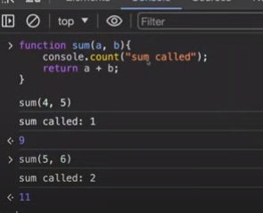

Time:

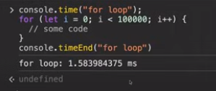

Koto khon time lage ber korte use korte parbo.

TimeLog:

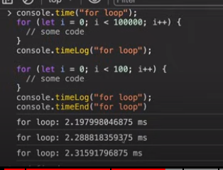

Timer akta application a shorbocco 10 hazar baj rakte parbo er bashi na eta browser er limitation.

Assert:

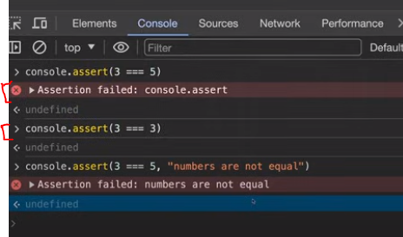

Assert er bitor condition diya check korte pari. Condition fail hole assertion failed dibe. Other wise kisu dibe na bujte hobe thik ache.

Console.Table:

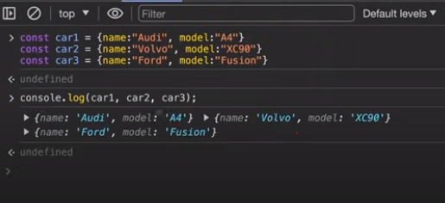

Then..

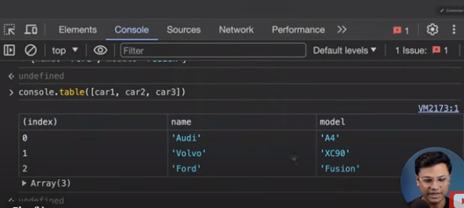

Shudu name dekhate chile… name bole dite hobe:

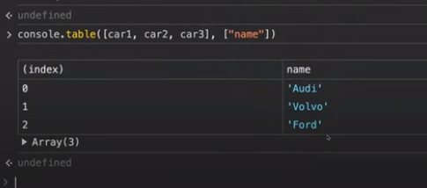

Name and model dekhate chile:

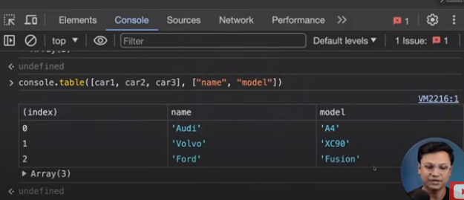

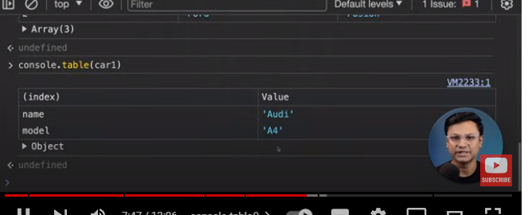

Console.group:

Ekta group:

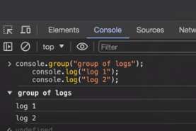

Ekta group:

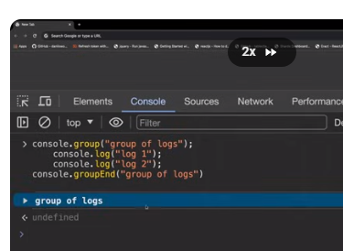

2 ta group er example:

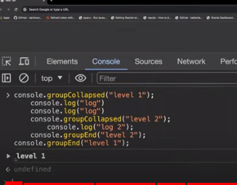

Collapsed name bondo hoiya ache jamon level 1 er modda 2 ta log ache.

Styling.console.log:

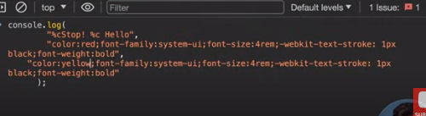

Output:



Er maddome console.log ke je kono stype dite pari amra.